**QUESTIONS and ANSWERS**

**Q1. How is vaccination progress for the top 5 rich countries?**

Rich country in the sense of having highest GDP per capita. For this, I downloaded another dataset containing information about GDP per capita and merged to our country-wise vaccination data frame. I sorted the data frame according to the GDP per capita and show the table for the top 5 rich countries, have a look at the table:

It seems like, Luxembourg has covered 74% of its population with complete immunization. One can notice here in the above table that except the USA all the other countries have a very low population less than 1 million and  
Norway is less than 10 million, and that’s why they have a very high GDP per capita and they have easily covered the complete immunization, but what about more populous countries? Let’s check

**Q2.How’s the vaccination progress for the top 5 rich countries having a population of more than Ten Million?**

Wow! as expected, these top 5 rich countries having a population of more than 10 million, have done a very nice job for their population, Except Australia, each one of them has covered more than 50% population with complete immunization, Canada and Belgium with more than 75%.

**Q3.Which are the top 5 countries with the highest percentage of complete immunizations?**

This might be the next question in your mind, and the answer is:

Singapore, Aruba with more than 95% while Israel, Iceland, and Seychelles with more than 85% are at the top position in view of the complete immunization.

**Q4.How much percentage share of population by dose 1 and 2 for top 10 most populous countries?**

Wow! India has covered 40% population with single-dose while, 12% population with complete immunization. The USA with 67% and 57% with single-dose and double dose.

From the above graph, we have seen that Nigeria is pretty much slow with the vaccination progress, If you look at the table and focus on the GDP per capita in Nigeria, you will find they have a very low GDP per capita and that’s why they are much far behind in the race of the vaccination process.

# **Summary**

First of all please accept my gratitude for the time that you had put into reading this article.

## Our journey from the beginning of the project :

* We first got introduced to our dataset.
* We then checked for missing values, duplicated values, and what are the data type available in the dataset.
* We then come to the visualization part, which is the best part of each of the EDA projects.
* We then answered some of the interesting questions that a person can ask in general.

## Key Insights from our Work

Finally, we brought some interesting conclusions from our work:

* United States: They have done a very great job with the vaccination process, they have covered almost around 57% of the entire population with complete immunization, the achievement they have got may be due to two reasons: First-They is a very strong country in view of GDP per Capita, and the second one is they are using a vaccine developed by the company Johnson&Johnson, which has single dose vaccination scheme.
* India: India is a very big country by its population and also does not have a good GDP per capita score, India has covered almost 40% of its total population with single-dose and about 11% of the population with complete immunization.
* China: Where this pandemic started firstly, and they started the research for vaccines to stop the spread of this covid-19 virus, but they didn’t perform their job perfectly, even they also have a good GDP per capita score than India.
* Countries with Good Vaccination Progress: It is difficult to vaccinate the entire country with a large population, but still, there are some countries that have done their job very seriously and they really deserve the right award for this. some of those countries are United States, Canada, Belgium, Australia and Nethersland.

1. The rate of applying vaccines to patients is highest in**Israel.**
2. Conjecture: It is because of its small size (in terms of both area and population), a relatively young population, relatively warm weather in December 2020, a centralized national system of government, and well-developed infrastructure for implementing prompt responses to large-scale national emergencies.
3. The **United States has the most vaccinated people of around 60M**of its total population followed by **China**and **the United Kingdom**.
4. Conjecture: Since these are developed countries the accessibility of the vaccine is easier to its public.
5. **Moderna, Pfizer/BioNTech** are the most popular vaccine used worldwide, since it has almost negligible side effects (known till date). Also, India uses **Covaxin, Covishield** for vaccinating its citizens.
6. Different countries are using various vaccines viz., **India** — Covaxin, Oxford/AstraZeneca, **USA** — Moderna, Pfizer/BioNTech, **Israel**— Moderna, Pfizer/BioNTech, **UK**— Oxford/AstraZeneca, Pfizer/BioNTech.
7. From the inferences and conjectures, it can be concluded that people from all parts of the world are educating themselves and willingly taking the vaccines under the governments’ free vaccination program. Also, these vaccines have been proved effective against COVID-19 (till now). If the rate of people taking the vaccine continues to grow then all the countries can vaccinate their people before the end of this year.

**Q5.Which country is vaccinating its citizens the fastest?**

For plotting, we need a set of values from the data to be arranged in a particular manner. It can be achieved by using methods like groupby(), max(), sort_values(), etc. Also, we will compare the first 10 countries for neat visualization. After arranging them we can plot them using seaborn built-in functions as shown below.

From the visualization below it is clear that **Israel**leads the world in terms of the number of doses per head of population, with**more than 80 doses** given for every 100 people.

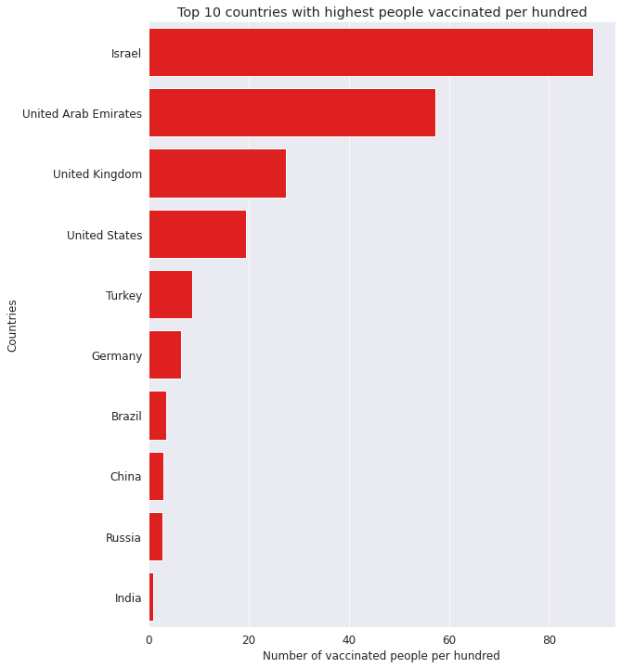

**Q6. Which country has the highest number of vaccinated people?**

Let us find out the country having the most vaccinated people. For easy visualization, we will consider the top 10 countries from all. Here we have used matplotlib to plot the data, along with using the total vaccinations' series.

It is clear from the visualization below that the **United States has the most vaccinated people around 60M.**

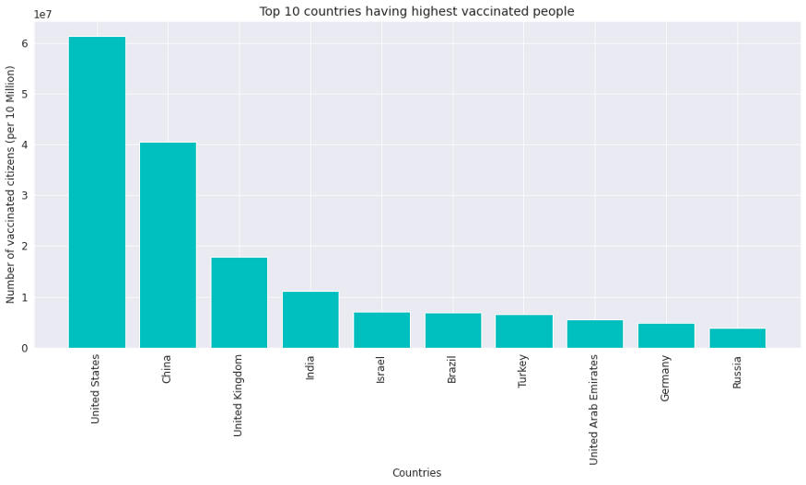

**Q7. What are the different categories of vaccines offered?**

For finding different categories and understanding which vaccine is used widely, I curated the code as follows:

**Pfizer** tops the list of most-used COVID-19 vaccines in the world, followed by **Mordema**, and **Oxford–AstraZeneca.**

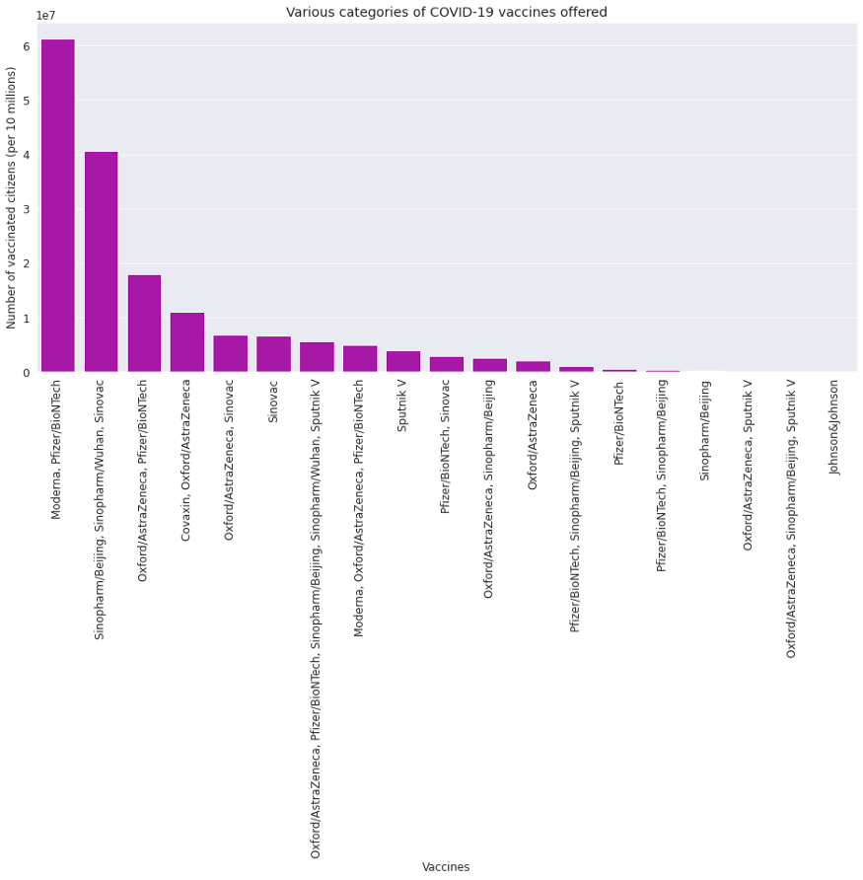

**Q8. What are the different vaccines used by different countries?**

In this particular objective, we are going to use the Plotly library to plot a 2-D map of the world. Here we have used iso_code for getting the location of a particular region/country. Also, the hover_name attribute is used for the creation of a dynamic chart so that when we hover over a particular country it shows the details of vaccines.

